**Model Development Phase Template**

|  |  |
| --- | --- |
| Date | 15 March 2024 |
| Team ID | xxxxxx |
| Project Title | Human Resource Management: Predicting Employee Promotions Using Machine Learning |
| Maximum Marks | 10 Marks |

**Initial Model Training Code, Model Validation and Evaluation Report**

The model validation and evaluation report will include a summary and training and validation performance metrics for multiple models. The details will be presented through respective screenshots.

**Initial Model Training Code:**

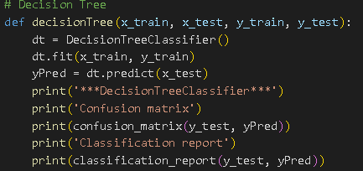

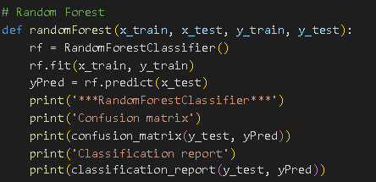

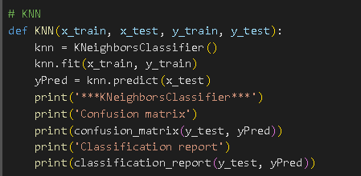

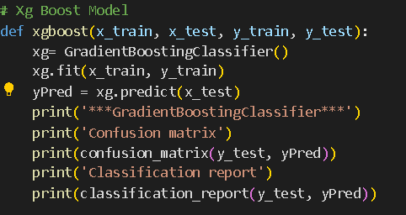

**Model validation and Evaluation Report:**

|  |  |  |  |
| --- | --- | --- | --- |
| **Model** | **Classification Report** | **Accuracy** | **Confusion Matrix** |
| Decision Tree |  | 94% |  |
| Random Forest |  | 96% |  |
| KNN |  | 91% |  |
| Xgboost |  | 96% |  |